**Project Report on Website Development**

**CHANGES CAN BE MADE IN UI/UX:**

* We can add a Tracker in our website. So that customer can track their order and can stay on our website for a long time this can also increase SEO of our website.
* There should be some links in the website which takes directly to another page which is very popular as when we use those links on our website then it will increase the sites SEO.

**HOW CAN WE ADD LIVECHAT/HELPCHAT MODULE IN OUR OPENCART:**

* Register on this site:
* <https://www.mylivechat.com/register.aspx>
* Now code is available, which is a java script file which has to be added in the website, copy that code.
* Now go to the opencart and then go to Extensions/Extensions/Analytics.

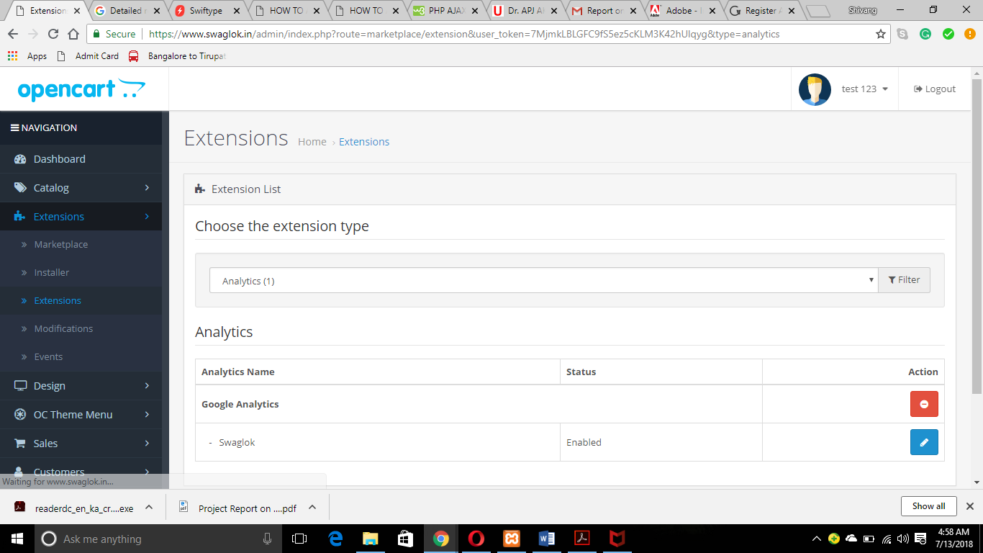

* Now we have to click on edit of swaglok as we can see in the screen shot.
* After clicking on edit we will be on the following page.

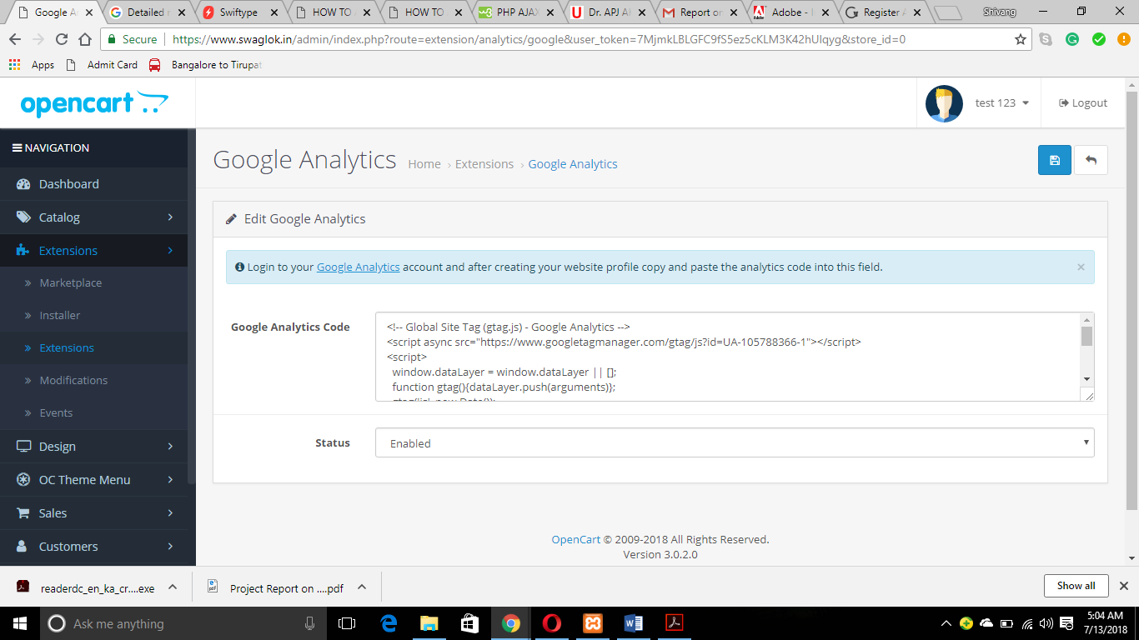

* Copy that code in the Google Analytics Code as bellow.

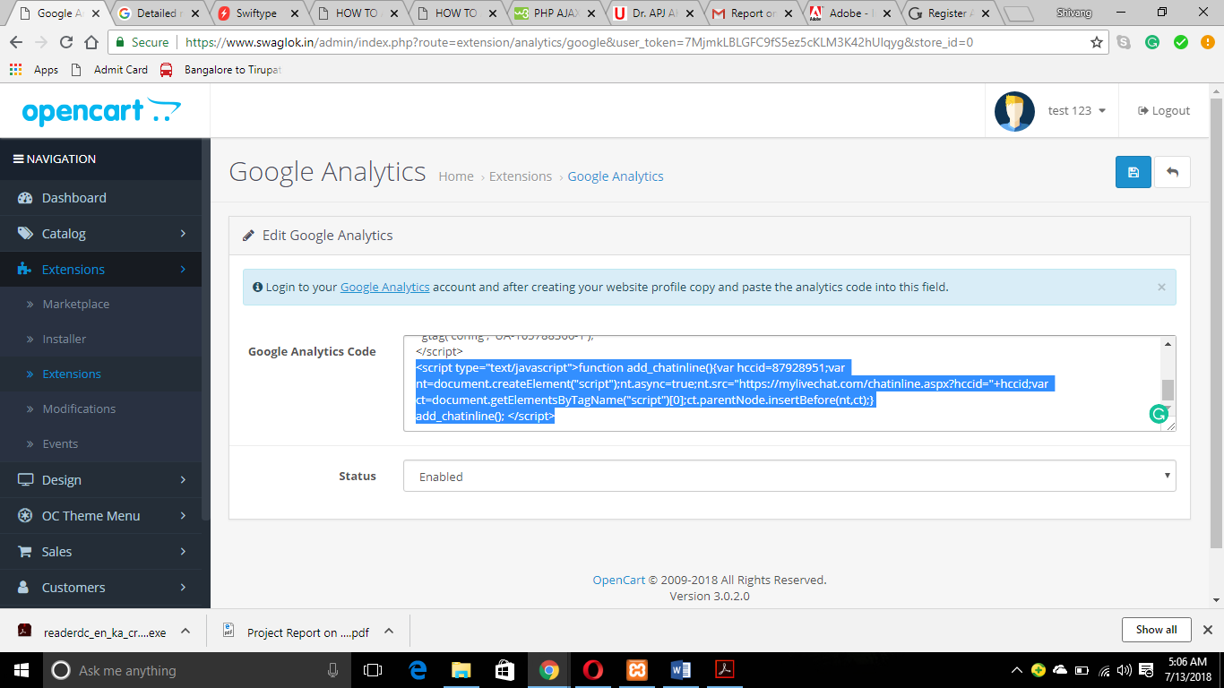

* Now save the changes.
* Now see the changes in the live site of Swaglok you will find Leave a Message module right there.

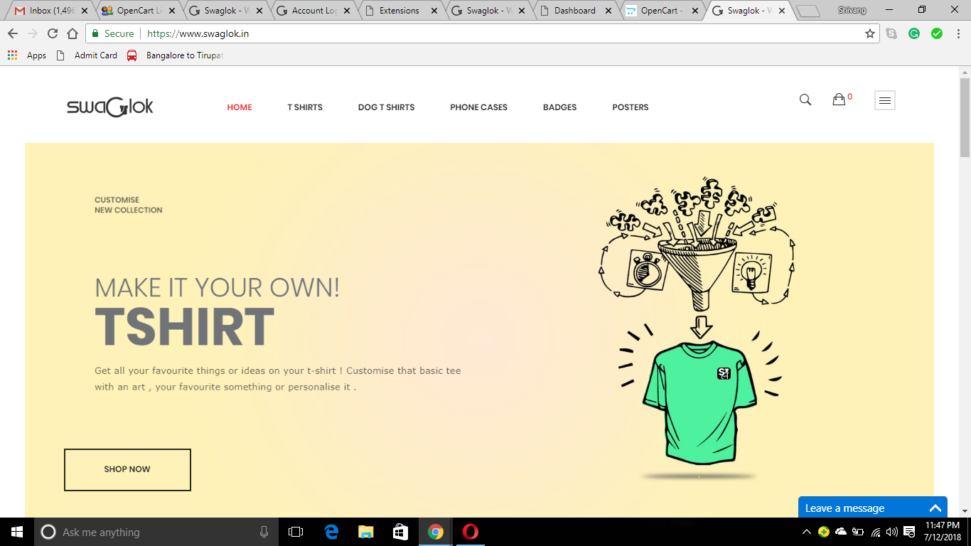

* This change is applied to all the pages of the Swaglok.

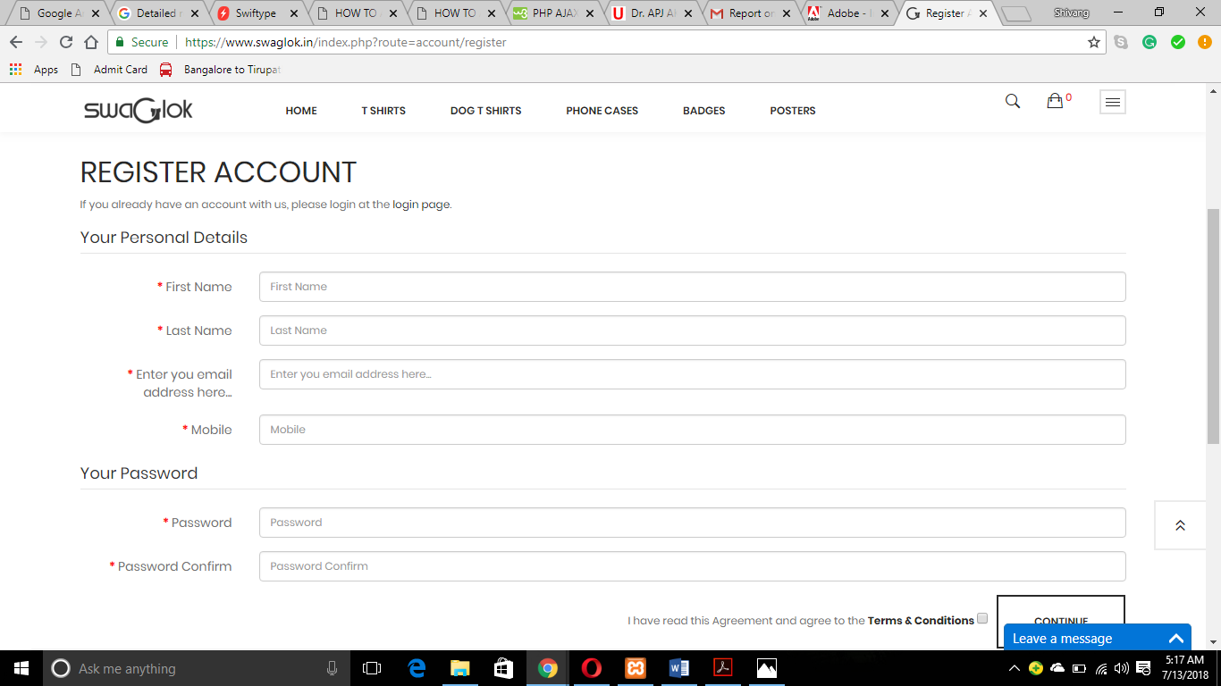

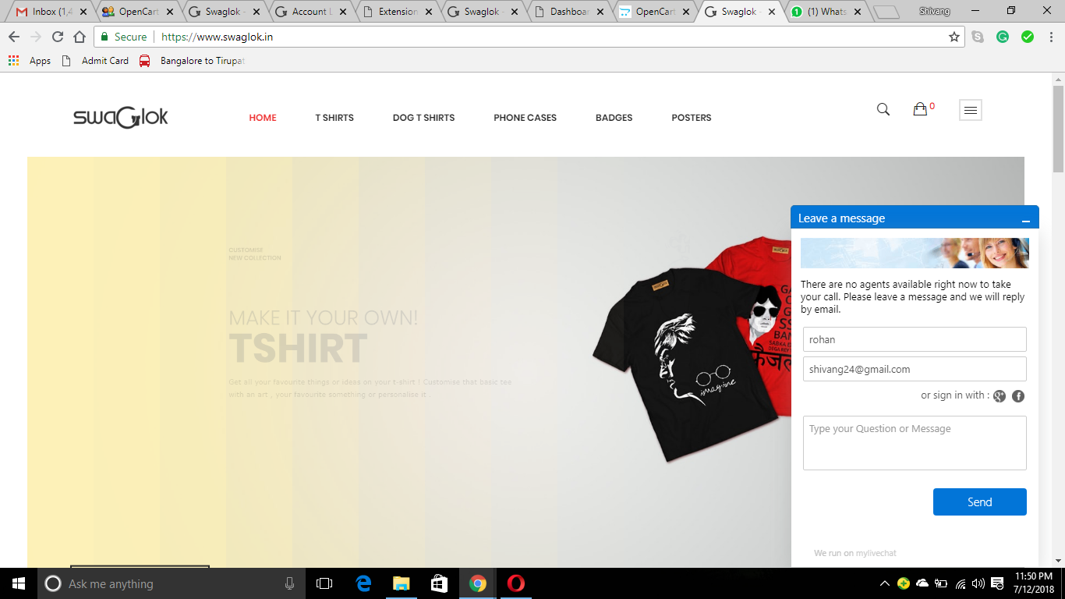

* Now go back to the site <https://www.mylivechat.com>
* Login here and you will get a nice dashboard where you can give an email where you want to get the mail.

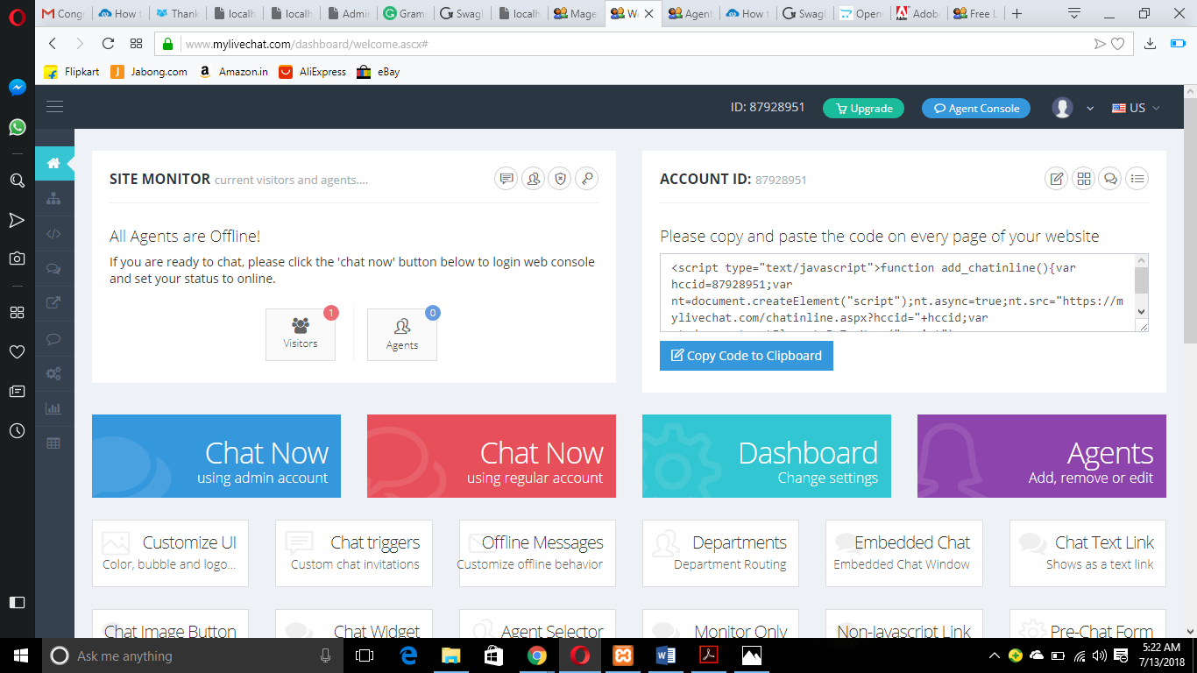

* Here you can see the visitors who message you and can see their location.
* This subscription is free for 1 month, so I think you have upgrade the plans to run this module.